Minutes for the 154th Meeting of the Faculty Senate
for Thursday, February 17, 2021 from 3:30 to 4:30 pm held virtually.
Attendance: John Verzani, Jane Marcus-Delgado, Alan Benimoff, Jonathan Peters, Cynthia Chris, George Sanchez, Catherine Lavender, Brian Farr, Cindy Wong, Simone Wegge, Wilma Jones, Katie Cumiskey, Thomas Tellefsen, Darryl Hill, Kerri Gerson, Sylvia Kahan, John Wing, Maurya Wickstrom, Natalie Fischetti, Alfred Levine, Peter Galati, Susan Holak, Gene Fellner, Christine Flynn Saulnier, Carles Solà Belda, Valerie Forrestal, Sarolta Takács, Yumei Huo, George Wang, Susan Imberman, Chang-Hui Shen, Michael Paris, Maryann Feola, Vandana Chaudhry, Roshen Hendrickson, Angelo Bongiorno, Vandana Chaudhry, George Vachadze, Hernan Green, Deborah De Simone, Carlo Lancelotti, Andrew Colbeck, Alyson Bardsley, Lucas Marchante, Jay Arena, John Lawrence, Michael Parrish, Jason Bishop, Orit D. Gruber, Comfort Asanbe

Guests: Warrick Bell, Hope Berte, Patricia Kahn, Robert Wallace, Suzy Shepardson, Juline Robinson, Jennifer Borrero, Veronica Dimeglio, JiaYu Chen, Tara Mastrorilli, Mark D. White, Linda, Donna Scimeca- CSI, Joyce Taylor, Beatrix Reinhardt, Christine Cohen, Debby Meise, Michael Chiacchiero, Danielle Dimitrov, Amy F. Stempler, Cesare Barreca, Alex Scott, Christina Hagedorn, Jessica Stein, Steven Monte, Dante Tawfeeq, Lynne Lacomis, MIke Cavagnero, Stephen Ferst, Catherine Ferrara, Terri Sangiorgio, Jessica Collura, Anat Niv-Solomon, Susan Massara, Alan Lyons, Florinda Mattia, Jennifer Durando, Qiao-Sheng Hu, Ralf Peetz, Eli Hollander, James, Jennifer Lynch, Katrina Fama, Celeste Del Maestro, David Pizzuto, Alex, Joanne LaPilusa, Donna Sipp, Greg Phillips, Stefanie Gardiner, Maureen Garvey, Angelina Raio, Comfort, Shelley Giannina, Patti Gross, T.J. Tibbs, Linda Conte, Michele Karpeles, Julio Valerio, Koby Kohulan, Winnie Brophy (CUNY), Nada Michael, Sabrina Ganam, Debbie, Janna Hemeda, Ricky Lui, Janine.Scotto, Andrew Mancuso, Michelle Borowski, Asemaa Sayedahmed, Dina Pattelli, Stephen Fried, Marwa, Titus Abubakarr Kambia, Andrew Leykam, Steven James, Anne Alarcon, Benedicta Gbemudu, Alan Hoffner (jhoffner), Caterina Scarimbolo, tony gallego, Isabel Rechberg, Shuqun Zhang, Jane Kisto, Sekou Blow, Matthew Ganz, Alex Scott, Debi Kee , Nobles Lilyon, Edward Patri, Melissa Lalla, Enza Vario, Terianne Darragh, Michael Lederhandler, Marsha Turner, deborah stengle, DAINA CHARLES, Stephanie David Allen, Chris Verene, Sheldon Briscoe, Andrew Leykam, Ismael García-Colón, Dmitriy Verkhovskiy, Jasmine Cardona, jodi, Neophytos’s iPad, Crystal Deosaran, Elizabeth Nieto, Maria Levine, Michael Dontis, César Arenas-Mena, Barbara Cohen, Leonardo Pignataro, Byron Taylor, TAIWO, Kristi Brescia, Sebastian Llivichuzhca, Christina Boyle, Brenda Valentin, Nicole Pellegrino, Janyah Mercedes, Penny Varriano, Marissa Davis

- Approval the agenda.
Motion made by the Chair to reorder the agenda so that the Research Committee could make its report earlier in the meeting was moved, seconded, and passed unanimously.
The reordered agenda was moved, seconded, and passed unanimously.

- Approval of the minutes of the meeting of the Faculty Senate of December 16, 2021.
Moved, seconded, and passed unanimously.

- Executive Committee Report: Appendix A
  - Academic Research Committee Report – Appendix B.
Comments: thanks to the committee for this excellent and very important report. The Humanities & Social Sciences faculty would like to recommend that the cuts to the Library be included in this report on the dwindling support of Academic Research.
Comment: The Faculty were reminded that: (1) CSI is a Hispanic serving institution and that there's lots of opportunities for institutional grants to support building diversity into STEM fields and other fields; (2) there are specialized institutional grants related to encouraging women and underrepresented groups in into stem that could build building pipelines from our area high schools into the College, which could increase enrollment.
Comment: Interim VP for Institutional Advancement, External Affairs, and Communications Kim Williams introduced herself and encouraged faculty to work with her on identifying available grants.
Comment: It was reported by Dante Tawfeeq, Interim Associate Provost for Graduate Studies, Research, and Institutional Effectiveness, that funds have been distributed to faculty in Accounting, Finance, Biology, Chemistry, English, Social Work, and Psychology. He reminded faculty that you do not have to be in the sciences to receive GRTI funding, but that there are certain requirements but he encourages faculty to work with him to get as much funding as you can.
Comment: We need a Research Czar – a point person for faculty to know who to ask and where to go for help. That person should also be the point for institutional grants and to be generating these conversations.

- Provost’s Report : Appendix C
Question: Thank you for listening to the faculty and conducting the student survey! Thank you for the WinterFest – can we do more to re-establish Community at CSI for our staff, students, and the faculty? Juniors and seniors are having difficulty transitioning. Faculty are having difficulty transitioning. The staff had and are still having difficulty transitioning. How can we help our community come together so we don’t establish a “commuter college” environment?
Answer: We definitely need to think about our juniors and those who are coming to the college for the first time. WE can definitely move slowly towards more activities in person for faculty, staff, and students.

Question: Is there a way that as a whole community, we could strategize how we approach our academic planning for next Fall with an eye toward Spring, to broaden our definition of hybrid – so we use our best practices of what we learned form hybrid and integrate aspects of on-line or remote aspects of instruction – this would allow us to free up space on campus for teaching or gatherings?
Answer: The answer to that is YES! We have to work with the registrar a=regarding what actually goes into the schedule, but we won’t be wedded to the 50% in person and we do have High Flex capability.

Question: Regarding the flexibility, how quickly will you know as that will impact students’ decisions on which classes to take? How did CUNY come up with the 70/30 policy and make it one size fits all?
Also, the cluster hire – how will the cluster hire work? Psychology is involved with all knowledge, science, art, humanities.
Answer: The 70/30 was not based on individual campus differences but was imposed. None f the Provosts liked it or knew how it was identified. Regarding the cluster hire, that will be something that the Deans and chairs will drive. The recommendation was mostly HHS driven.

- Reports of the Committees of the Faculty Senate

  - Admissions Committee – none
  - Curricular Committees – Chairs:
    - General Education Committee –
    - Graduate Studies Committee –
    - Undergraduate Curriculum Committee –

Consent Agenda for Thursday, February 17, 2021

AII. GENERAL DEGREE CHANGES
AII.1 DEPARTMENT OF PSYCHOLOGY: Psychology BS

AIII. NEW COURSES
AIII.1 DEPARTMENT OF PSYCHOLOGY: PSY 241 Child Development

AIV. CHANGE IN EXISTING COURSES
AIV.1. DEPARTMENT OF PSYCHOLOGY: PSY 242 Developmental Psychology
AIV.2 DEPARTMENT OF PSYCHOLOGY: PSY 335 Experimental Psychology: Child Development
AIV.3 DEPARTMENT OF PSYCHOLOGY: PSY 342 Language Development
AIV.4 DEPARTMENT OF PSYCHOLOGY: PSY 343 Infancy
AIV.5 DEPARTMETN OF PSYCHOLOGY: PSY 345 Motor Development
AIV.6 DEPARTMENT OF PERFORMING AND CREATIVE ARTS: ART 105 Discovering the NY Art Scene
Consent agenda was moved, seconded, and passed unanimously.

  - Course & Standing – none
  - Library Committee – none
  - Academic Research Committee – Appendix B.
  - Academic Facilities Committee– none
  - Academic Freedom Committee– none
  - Academic Technology Committee– none
  - Faculty Personnel Policy Committee – none

- University Faculty Senate Report – none

- Old Business- none

- New Business – Policy on Absences for College Sanctioned Activities – Appendix D

Recommendation that this policy be put through one of the FS subcommittees so it can be properly vetted

IX. Adjournment. Motion made, seconded, and passed unanimously at 4:37 pm.

APPENDIX A
Faculty Senate Executive Committee Report
February 17, 2022
I am pleased to welcome everyone back for the spring semester. I hope that we are starting a great year at CSI, with the possibility of finally ending the long pandemic and the welcoming of our new President, Timothy Lynch to campus. As I stated in my remarks last December, this community has more than proven its resiliency in the face of adversity and we are looking forward to a renewed sense of community and solidarity.
I would like to mention several comings and goings on campus. First, we are pleased to welcome Dr. Burnett Joiner, our new Interim Dean of the School of Education, to campus. We also have several outstanding faculty and staff members who have left the CSI community in recent months. Two faculty members, Natalie Fischetti and former Dean of Humanities and Social Sciences Francisco Soto, have retired, and our Registrar, Kerri Gerson, has resigned. We are especially saddened by the death of Arnie Kantrowitz, who was a much loved and respected member of the English Department for many year. We are sure that there are a number of other retirements, resignations and life events that have affected members of our community and regret not acknowledging all of these important milestones.
I join many others in the CSI and CUNY communities in welcoming our new Interim President. The Faculty Senate Executive Committee had the pleasure of meeting with President Lynch, and we held a wide-ranging discussion about many of the issues concerning our faculty and staff. We were heartened by Dr. Lynch’s openness and commitments to improving communication, transparency and shared governance at CSI. We expressed concerns about issues ranging from the budget to funding and support for research and modes of instruction. We look forward to further conversations with President Lynch on these and other subjects.
We have not received any information about the search process for a new president, but we are extremely committed to ensuring faculty participation on the committee and in the process. We will communicate all information we receive about this to the Senate members.
The Faculty Senate Executive Committee also met with the Provost, the Associate Provosts and the Deans on February 8. Among the topics discussed was the subject of modes of instruction. We had previously met with the chairs of the Curriculum committees and the Deans to talk about this subject. We emphatically reiterated the importance of faculty primacy in deciding which courses should be taught remotely, in-person or in hybrid modes. These decisions should be made in coordination with chairs and deans, and we stressed the importance of local decision-making on these matters. We urge the Administration to develop a longer-range vision of CSI’s online presence and we are committed to participate in the process.
The Executive Committee has also been reviewing our Consent Agenda for Curriculum. We strongly recommend that all Senate members carefully review the agenda prior to our meetings. Any Senate member may request that an item be removed from the Consent Agenda and brought to the floor for discussion. Fortunately, the curriculum committees do an excellent job of reviewing curricular items, so the bulk of changes and decisions are competently carried out at the committee level.
We will spend some time today hearing from the Research committee and others. As CSI and CUNY contemplate the hiring of hundreds of new faculty as Lecturers, we wish to remind our community that we are a comprehensive college. Research needs to be restored to its previous status in the front and center of our work as faculty. As the numbers of tenure track faculty continue to shrink, our colleague’s scholarship becomes increasingly critical to the intellectual health of the institution. We ignore this component of our profession at our (and society’s) peril.
Best wishes for a wonderful spring semester.
Respectfully submitted,
Jane Marcus-Delgado
Chair
APPENDIX B
Academic Research Committee Report
February 17, 2022
Report from the Faculty Senate Research Committee.
- The current decline in research and scholarship funding compromises the stated mission and goals of CSI as an institution of higher education. These problematic trends are reversing the historic role of CUNY to provide equal opportunities to students from diverse social and economic backgrounds.
- The findings of the Research Committee of the Faculty Senate, are summarized in two reports.
- The first report summarizes the complete elimination of research incentives for faculty and students regularly provided in the past.
- The second Report summarizes the annual research support over the last four years in several categories.
  - The total support of research and scholarship is funded by CSI and by indirect funds obtained as institutional support in grant awards. These funds are provided in addition to funds directly related to the costs of the research project. The amount of indirect funds gained by funded faculty research projects (grants) remains stable at about half a million dollars per year. However the institutional support has declined from one and a half millions to one million per year during the last four years. Thus, indirect funds represent now one third of the total funds, from a previous one fourth contribution.
  - Fortunately, the support for personnel and release time has been maintained.
  - Costly equipment maintenance contracts have been eliminated. However, no rainy funds have been allocated to replace and fix equipment, causing great uncertainty and disruption to research projects of faculty and the academic progress of our undergraduate and graduate students.
  - The support per graduate student in the form of graduate assistant contracts has strongly declined by 50% in the last four years. Fortunately, the overall number of PhD students remains stable, but these numbers are bound to decline once their support becomes entirely dependent on faculty grants in four years, given the current trend. Graduate assistants are part of the PSC-CUNY bargain unit and their contribution to the institution seems sometimes underappreciated. The actual graduate assistant support represents the difference in cost from hiring an adjunct instructor or CLT with the same workload but no research obligations.
- The Research Committee has elaborated the following recommendations.
  - Re-establish or regularize some form of return of indirect funds to departments/divisions of origin. Regularize administration and transparency of indirect-funds distribution
  - Stablish Rainy Day Funds to substitute for the elimination of maintenance contracts
  - Plan to allocate startup funds for future professorial hires
  - Restitute previous level of research and scholarship support. Detailed in Document prepared by Mark Lewis.
    - Travel Support as mandated by PSC contract
    - Provost Research Scholarship
    - Dean’s Research Grant
    - Scholarly Reassigned Time Awards
    - Provost Travel Scholarship Award
    - Undergraduate Research Support
    - Provost Fellowship leave
  - Promote submission of institutional grants, ex. educational innovation etc.
    - Release time for proposal preparation. 3 full time faculty equivalents.
    - Annual competition with one page white paper
    - Administrative and clerical support
  - Regularize and expand Graduate Assistant B lines
  - Reconsider 72% indirect on salary and wages to a more conventional formula
  - Elaborate a 3 year plan to promote research and scholarship at CSI

- In order to further discuss and elaborate solutions to these important issues for the future of CSI, the Research Committee request to the Faculty Senate the convocation of a Town Hall Meeting about Research & Scholarship at CSI during spring 2022.

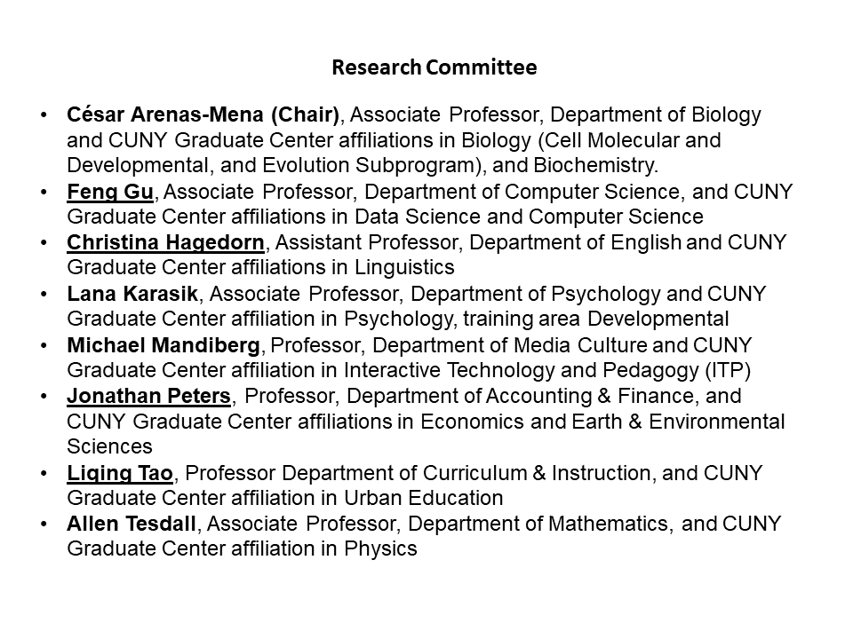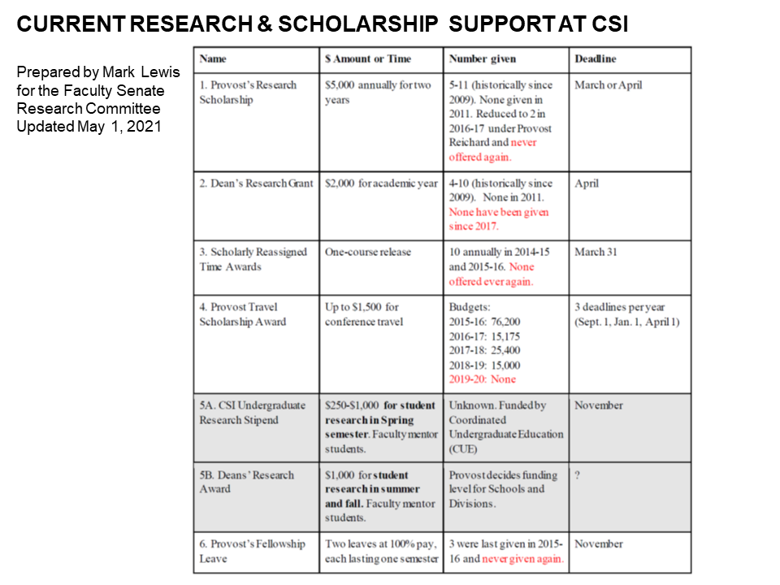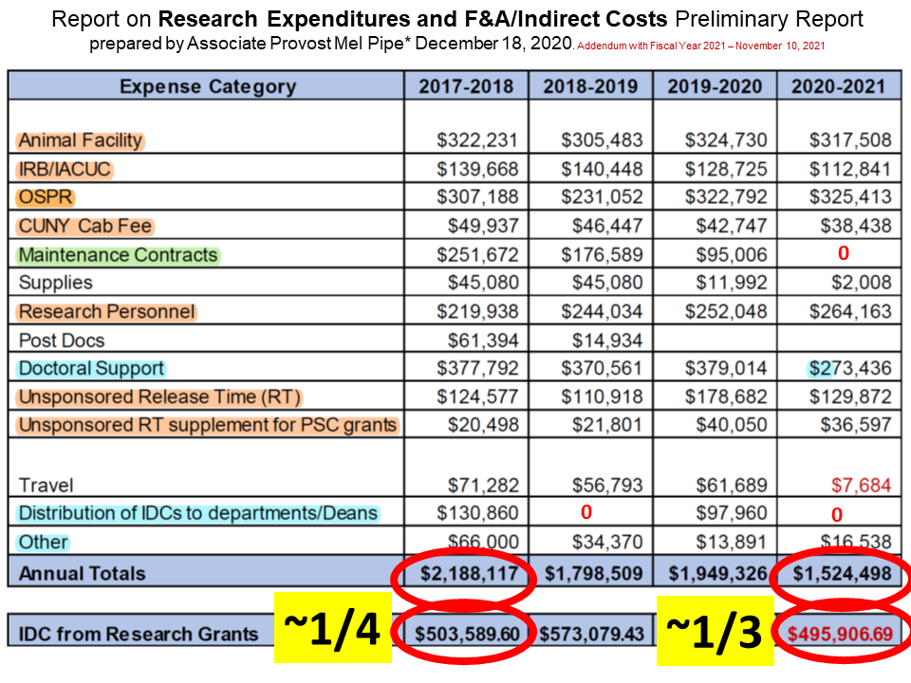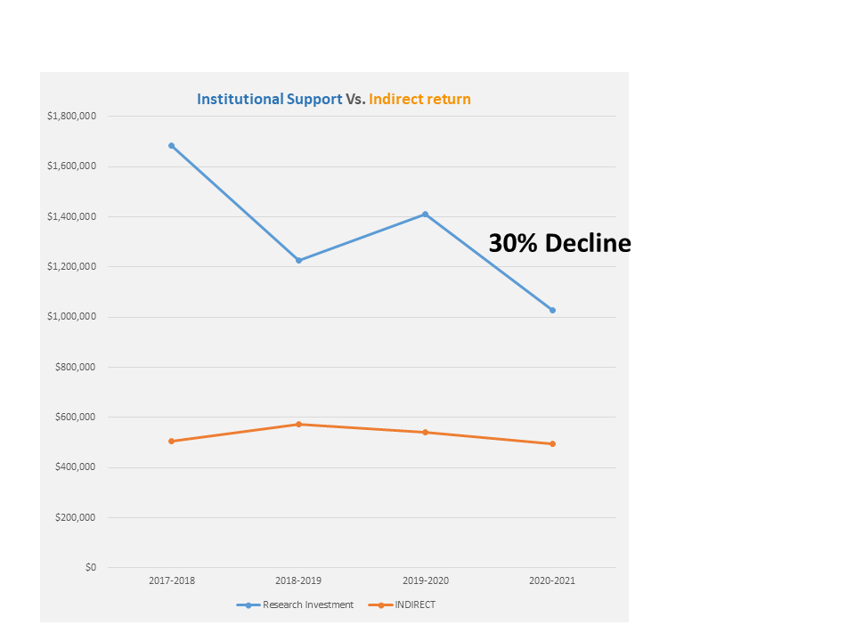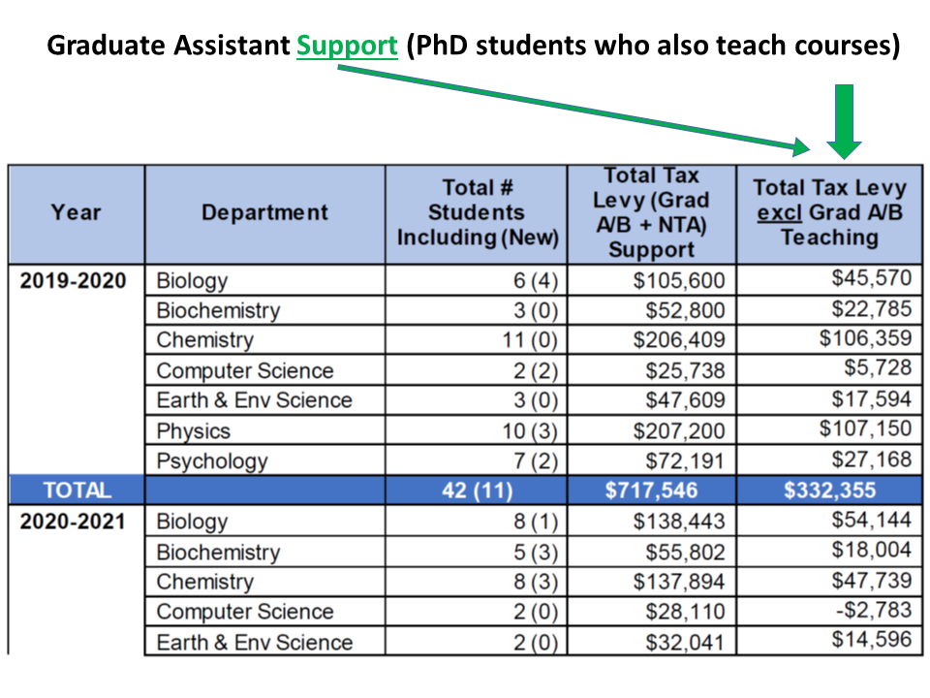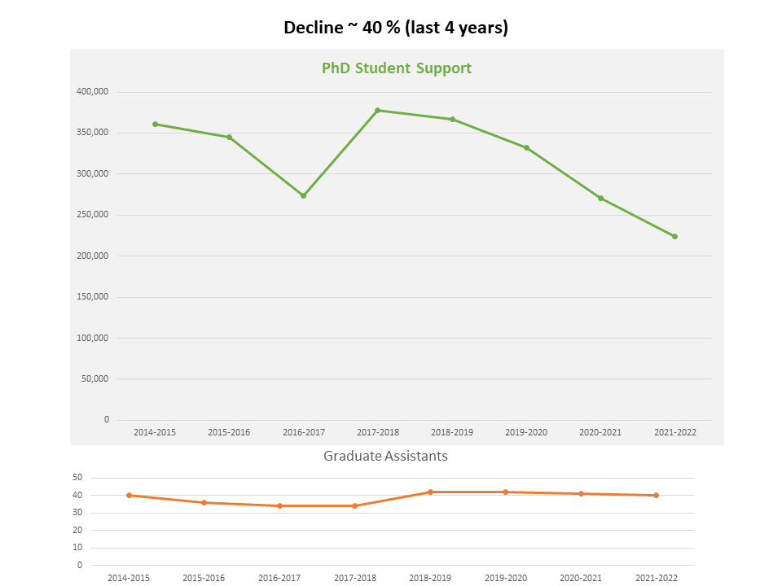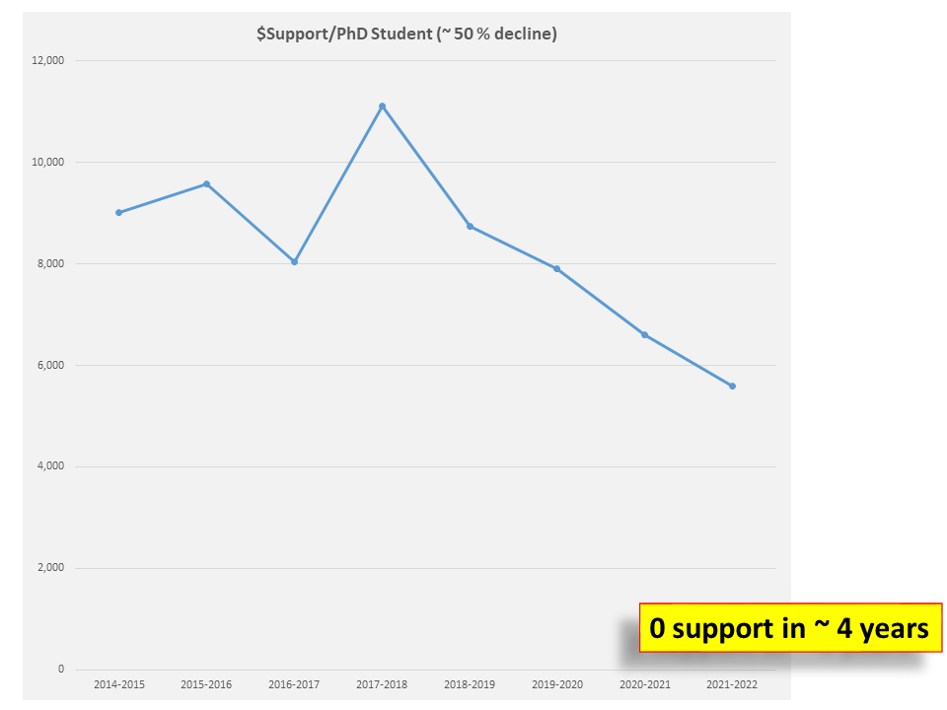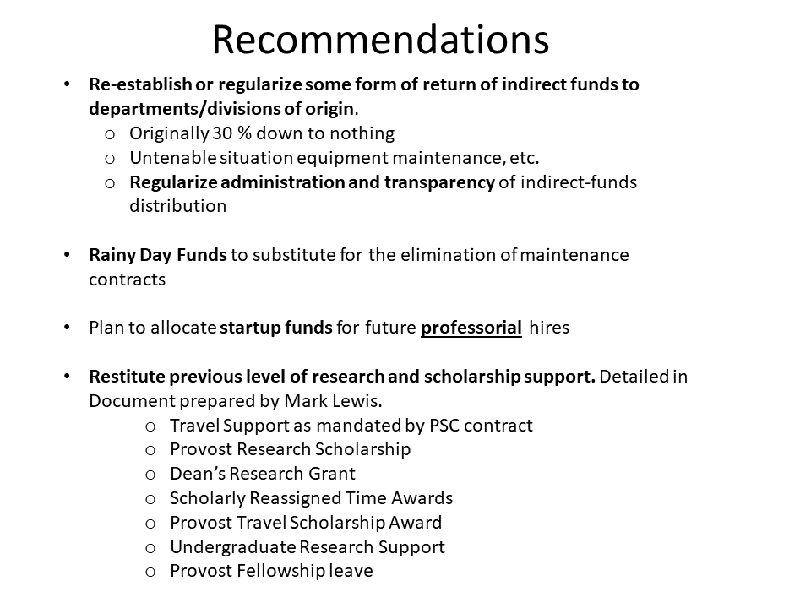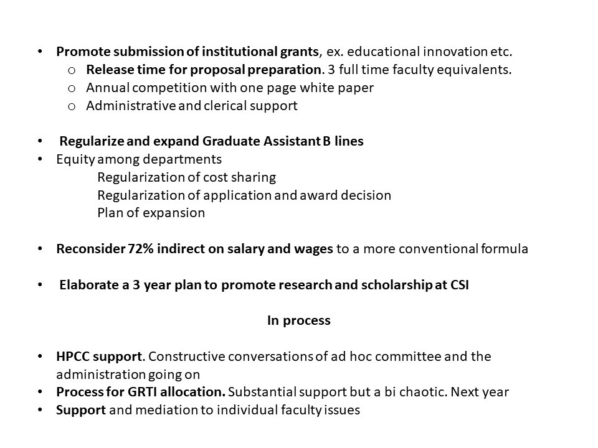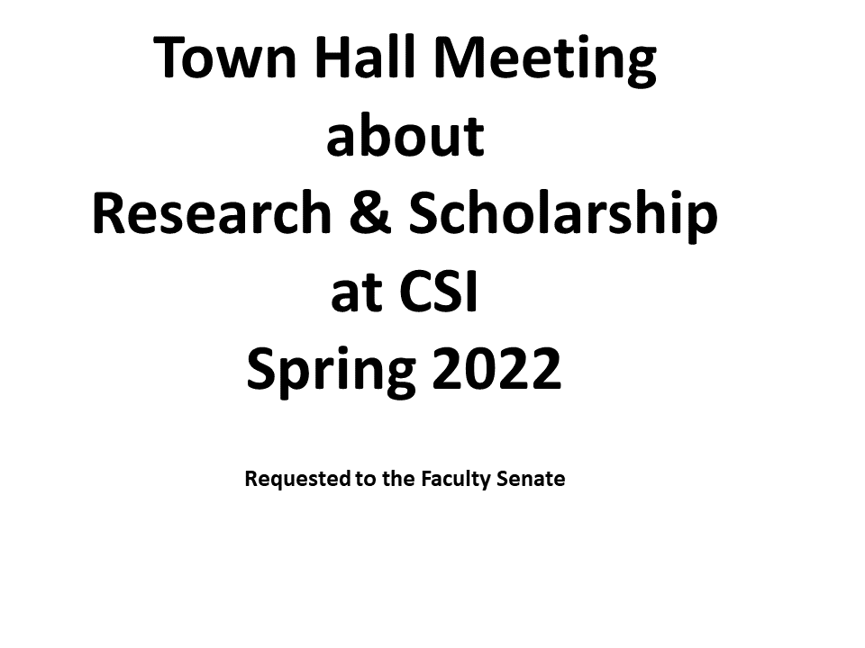
ADDENDUM ITEMS
A. DETAILED OVERVIEW OF PROGRAMS
1. Provost’s Research Scholarship
Offered by the Office of Academic Affairs $5,000 annually for two years
Historically, between 5 and 11 were awarded each year from 2009-2015. However, none have been awarded since 2016-17, and none were awarded in 2011. Applications are usually due in March or April. Faculty can receive this more than once.
From the RFP:
“Overview: The Provost’s Research Grant is given for a period of two years in support of faculty scholarship with the purpose of either attracting external research grants, contracts or of being awarded prestigious fellowships or residencies (i.e NEH, NEA, Fulbright, Guggenheim). Those faculty pursuing grants are encouraged to use some of the funds to travel to funding entities, especially federal agencies, to discuss specific RFPs or solicitations to generate grant proposals. The Provost Research Grant funds may also be used for research related travel, summer salary and student support. The grant is not intended for the purchase of routine supplies.
Expectations: The Provost’s Grant is given in support of building the research and scholarship of faculty. It is expected that each faculty member receiving the award will submit at least two proposals for external funding to agencies that allow overhead or will apply for two national/international fellowships. It is also expected that faculty will produce a tangible record of scholarship activities over the two year time frame. A short interim report is required by July 15, 20xx. Continuation of funding for the second year is contingent on the progress made during the first year. A final report, describing activities and a list of works submitted/published and grant or fellowship proposals submitted during the two-year period, is due July 15, 20xx+1.

Selection process: The selection committee will recommend a slate of candidates to the Provost. While all tenured or tenure-track faculty are eligible to apply, preference will be given to junior faculty trying to build their scholarship and to faculty who are considering changing to a new line of research. Faculty may apply for both a Dean’s Scholarship and a Provost’s Research Scholarship but will not be awarded both.”
2. Dean’s Research Grant
Offered annually by Divisional Deans. This will be expanded to include the Schools, according to an email from Jessica Stein in 2016.
$2,000 for the academic year
Historically, between 4 and 10 were awarded each year from 2009-2015. However, none have been awarded since 2015, and none were awarded in 2011. Applications are usually due in April
From the RFP:
“Overview: The Dean’s Scholarship Award is given to allow faculty members to dedicate their time to furthering and strengthening their research, scholarship, or creative agendas.

Expectations: It is expected that faculty will use the award in support of their research, scholarship, and creative activities. A report (maximum of 2 double spaced pages) is required at the end of the scholarship period and will be due on July 20xx. The report should describe the product of the scholarship period. This may be a grant, a peer–reviewed article submitted for publication, or an equivalent product.
Selection process: A selection committee will recommend a slate of candidates to the Deans. All tenured or tenure-track full-time faculty at or below the rank of associate professor who have not received this award before are eligible to apply. However, strong preference in the selection process will be given to untenured junior faculty trying to build their scholarship and to faculty who have not received this award before. Faculty may apply for both a Dean’s Research Grant and a Provost’s Research Grant but will not be awarded both.”
3. Scholarly Reassigned Time Awards
www.csi.cuny.edu/privacy/ScholarlyReleaseTimeAwardPolicy.pdf
Offered annually by the Provost
Release time for one course, given to ten faculty (Note: There is no formal rationing system for divisions and schools.)
Chairs may nominate multiple candidates
Nominations are supposed to be for candidates who have “exceed departmental expectations.” This depends on department, Division, and School. For Science and Technology, it mean "publications in top tier journals and grants received." For Humanities and Social Sciences, individual departments and their chairs decide. The School of Business considers publications and external recognition. The School of Health Science considers publications and key-note speaking. The School of Education considers “exceeding department standards” to mean multiple publications in a single year, as well as a major grant. Nominations by March 31
From the Provost’s “policy document” (link above)
“Timing:
• Awards for an academic year are solicited and announced during the preceding spring semester.
• Scholarly work eligible for nomination must be completed and published or performed during the calendar year preceding the year of the award.
Eligibility: • Only tenured members of the faculty are eligible for this award.
• Faculty members receiving reassigned time during an academic year for external grants are not eligible for the award that same year. • Only accomplishments exceeding departmental standards are eligible for nominations.

Process:
• Nominations are made by chairs and are based upon the recommendations of the departmental appointments committee.
• Nominations must include a current CV and a letter describing the significance of the accomplishments during the previous calendar year.
• Nominations must be received by March 31 and should be sent to Jessica Stein in the Provost’s Office. • Departmental nominations are examined by an award committee consisting of the academic deans and selected members of the Faculty Senate Research Committee, which then makes recommendations to the Provost.
• The Provost makes the final decision regarding all awards.”

4. Provost Travel Scholarship Award Program http://www.csi.cuny.edu/administration/academicaffairs/pdf/ConferenceTravelFundingOpportun ity.pdf
Provides travel funding opportunities for faculty presenting their work at national and international conferences. Administered through Faculty Center for Professional Development Proposals are reviewed by faculty serving on the advisory board of the center. Recent amounts per applicant were very low—around $250 per applicant.

The total budgets were the following:
2018-19: $15,000
2017-18: $25,400
2016-17: $15,175
2015-16: $76.200

From the CFP:
“Eligibility: Tenure-track faculty will be eligible to apply if they are presenting the results of their research, scholarship, performance, or the scholarship of teaching and learning at a peerreviewed national or international conference. In limited instances, full-time lecturers will also be eligible to apply to attend a conference in their area of specialization or the scholarship of teaching and learning. Given the competitive nature of the process and the goal to enable as many colleagues as possible to participate, we would not expect to fund a faculty member for more than one conference within the above time period.”

5. A. CSI Undergraduate Research Stipend Program (formerly known as Dean’s Undergraduate Research Fellowship). These are actually programs for undergraduates; faculty serve as mentors.
Range is $250-1,000
Student must present at Undergraduate Research Conference in April Faculty mentors research student, receives no release time or teaching credit unless student signs up for an independent study Typically had a November deadline.
Process: Students submits application and budget. Review committee ranks applications. In the past, the Director of Verrazano Honors Program and Macaulay Honors College at CSI decided the exact amount a student received.
NB: This was funded by Coordinated Undergraduate Education, called CUE.

5.B. Deans’ Research Award
Funds student research in the summer and fall Total amount is $1000. $500 is issued at the beginning; $500 is awarded at the end after the student submits a research report. Student must present at annual Undergrad Research Conference in April Awarded annually
Process: Provost decides how much funding each School and Division receives; Deans decide student winners.

6. Provost’s Fellowship Leave
Offered annually by the Office of Academic Affairs. Last offered in 2015-16.
Two leaves at 100% pay, each lasting one semester The terms of 100% pay following the same contract terms as in the PSC-CUNY contract; if a faculty member takes 100% pay, he/she cannot take another leave until six years have passed.
Applications due in November
From the RFP:
“Overview: The Provost’s Fellowship Leave is given in support of scholarship to full-time faculty eligible for a fellowship leave under the terms of the CUNY leave policy. Preference will be given to faculty with strong records of scholarship. These fellowship leaves are given for the purposes of supporting publication in top scholarly outlets and/or developing proposals for external research grants/contracts. It is expected that recipients will use the fellowship leave for activities such as preparing manuscripts for scholarly publication, conducting research in order to generate a research proposal, attending grant writing workshops, and/or visiting potential funding agencies to generate proposals.
Expectations: Since Provost’s Fellowship Leaves are given to support research and scholarship, recipients are expected to produce a tangible record of scholarly activities in the form of publication and/or a significant grant application during the leave period.
A short report (maximum of five double spaced pages) will be required at the end of the scholarship period describing activities and giving a bibliography of works and grant proposals published/awarded or submitted during the period of award.
Selection process: Proposals will be evaluated by a committee consisting of five members of the P&B Committee. The Committee will forward its recommendations for awards to the Provost.”

B. RECOMMENDATIONS (AS OF MAY 1, 2021)

1. Travel funds mandated in the PSC-CUNY Contract should be accounted for. At a December 2020 meeting, former Associate Provost Mel Pipe and Provost Michael Parrish stated that PSC funds provide approximately $42,000 annually for research-related travel expenses. The total travel expenses for three years from $71,282 (2017-28), $56,794 (2018-19), and $61,689 (2019-2020). Since travel was not allowed starting in March 2020, there should be funds left from the rest of fiscal year 2020 and fiscal year 2020-21. These accounts should be identified and ear-marked for distribution in academic year 2020-21. Many faculty could use these to register for online conferences, for example, and some conferences have resumed in-person meetings.
2. Funding should be secured regularly for all programs. The Provost’s Research Fellowship, Provost’s Fellowship Leave, and Dean’s Research Grants were apparently eliminated after 2016. This could explain why the number of outside research grants has declined since then. Given that the College told Middle States reviewers from the previous review that these were part of ongoing research support, and given that faculty satisfaction with research support at CSI is low, regular funding should be a priority.
3. The irregular funding levels of the Provost Travel Scholarship Award Program continues to cause concern. Bringing this back to its 2015-16 levels is a relatively minor investment. It should be funded with federal funds that CSI received from three federal aid packages during the pandemic.
4. The Deans’ Research Grants were originally created in the era when there were two divisions at the college. Because there are now two divisions and three schools (Health Sciences, Business, and Education), they should be expanded. The Committee discussed this with the administration back in 2016.
5. In the past, the Provost’s Fellowship Leave consisted of two fellowships, each offering a faculty researcher with 100% pay for one semester. As noted in the chart, these have not been given since 2015-16— a five-year pause. These must be reinstated before the next Middle States review.
6. In December 2020, former Associate Provost Mel Pipe and Provost Michael Parrish conveyed that prior to fiscal year (FY) 2017, “up to 33% of indirect research costs were distributed back to those departments generating them, based on a sliding scale.” This was cancelled in 2018 and no monies were distributed from FY 2017. Then, in 2019, the administration distributed funds from FY 2018 according to a new formula: 10% of net IDCs were returned to departments and 10% were returned to Deans to incentivize additional funding. We would like to learn what happened to the funds for fiscal years 2019 and 2020 and provide input about spending priorities for the coming academic year.

C. Report on Research Expenditures and F&A/Indirect Costs; Preliminary Report prepared by Associate Provost Mel Pipe* December 18, 2020 (Addendum with Fiscal Year 2021 – November 10, 2021)
This report provides an overview of several areas of research support provided by the College of Staten Island to which facilities and administration (F&A) recoveries contribute. It is not intended as an exhaustive accounting and does not include, for example, many of the costs of the infrastructure supporting research for which F&A recoveries from grants are intended, such as facilities costs and maintenance of the physical plant, the library, and so on. It is inherently difficult to identify these specific costs, and thus F&A (or indirect costs, IDCs as they are also known) are included as a percentage of grant funds requested as opposed to direct costs on a grant.
Grant Funding: Direct vs. Indirect Costs Whereas direct costs are those needed by the principal investigator to carry out the research, for example, the costs of personnel, contractual services, supplies, and equipment, indirect costs are those that are needed to support the research but are difficult to quantify and allocate to each individual project. These include heat, electricity, administrative support, space, infrastructure, etc. Indirect/F&A costs are calculated as a percentage of the direct costs and are added to the grant request. They are returned to the institution to cover the costs of hosting the award activity. The indirect cost rate for any institution is renegotiated from time to time with the Department of Health and Human Services and at CUNY this is done by the Research Foundation. CSI is what is known as a short-form institution for the calculation of indirect costs; indirect costs are based on a percentage of the direct costs of personnel and wages only for most research grants. The current rate for federal grants is 72% of direct personnel costs. Some sponsors set limits and/or use “MTDC” (Modified Total Direct Cost), based on several expenditure categories. For more detailed information see the Research Foundation Website and also the NIH description of direct costs vs F&A.
The CUNY Research Foundation is the fiscal agent for the College and manages all external research grants. IDCs are not immediately available when a grant is funded, rather they are generated as grant funds are spent on a daily basis. Following the deduction of the Research Foundation fees, which are applied to all expenditures, the indirect costs generated are returned to the President’s Facility and Administration account. These funds can then be used to directly cover costs, including mandatory CUNY fees, to reimburse the College for infrastructure and research expenditures, for strategic priorities, to incentivize further grant funding, and so on.
The Table below shows the net IDCs generated by research grants for financial years 2018 – 2021, approximately $500 - $550k. Also included is the research support provided by the College to which these IDCs contribute.
Examples of how IDCs are used by the College include:
CUNY IRB fee (mandatory), CAB fee (mandatory) Animal facility costs Start-up funds for new faculty
Training for students and research staff Office of Sponsored Programs and Research Support of Research Personnel Support of equipment/maintenance contracts Research Protections Program Manager Unfunded research release time Doctoral student support
The IDCs generated by grants do not cover all of these and the infrastructure expenses, and tax- levy funds provide the remaining support.
For many years, in addition to IDCs being used centrally to contribute to research expenditures, up to 33% of IDCs were distributed to those departments generating them, based on a sliding scale. In 2018, in light of the then-budget situation, a preliminary analysis of the research-related costs that the College was covering from tax-levy funds and funds in department and center accounts accumulated from previous years‘ distributions (approximately $700,000, ranging from less than $10,000 to over $200,000 across departments), the Provost and administration made the decision that there would be no distribution of IDC recoveries from FY17. The Provost met with department chairs/program directors; departments with existing commitments from their IDC recovery accounts that could not be met by existing funds were advised they could make a request to the Dean and Provost to meet those existing commitments. In 2019, a distribution from FY2018 was made based on a modified formula, following a review of (and more in line with) other CUNY Senior Colleges; 10% of net IDCs generated were returned to departments and 10% to Deans to incentivize additional funding or provide support in areas where funding is not easy to obtain but some support is needed.
The Associate Provost’s office has been reviewing research expenditures, the first time a comprehensive review has been undertaken in several years. One area in which the College has reduced spending is equipment maintenance contracts. A review of the use of maintenance contracts showed that the College had been spending more than $200,000 on contracts some of which had never or seldom been used. It was concluded that it would be better, for example, to replace old items of equipment and retain contracts on a relatively small number of expensive instruments/pieces of equipment.
The College is committed to supporting research across Academic Affairs. Tight budgetary constraints call for careful management and for ensuring that expenses that can be included on external grants, relating to research facilities, are included as direct costs and that we are optimizing the use of the funds spent on research to ensure that all areas of research and scholarship are supported.

Explanation of Categories
Animal Facility: Personnel include 4 Full Time (FT) and 2 Part Time (PT) positions; 2 PT were replaced by 1 FT position in 2019. One additional PT position is vacant. Includes consultant Vet, supplies. Supports research in Biology, Chemistry, Physical Therapy, Psychology. User fees cover additional expenses which have typically been in the range of $3,000 to $10,000 per year.
IRB/IACUC: A Research Protections Program Manager (resigned 5/28/2021) and a (mandatory) IRB fee paid to CUNY. A PT position was added in FY 2018 and discontinued in FY 2020.
OSPR/Research: Three FT positions in OSPR + PT support (.5 HEA Office of Associate Provost). In FY 2019 one FT position was vacant
CUNY CAB Fee: A Central Allocation Budget (CAB) fee collected by CUNY to support research programs at the campuses (this is separate from RFCUNY's administrative fee).
Maintenance Contracts: Contracts for maintenance of equipment in the Imaging Facility, Animal Facility, Biology and Chemistry Departments, most through REMI. In FY2021 the REMI contract was temporarily suspended due to limited on-campus lab and equipment use.
Supplies: Air gases/dry ice used for research by several researchers.
Research Personnel: Three FT Research Associate positions and PT admin support. In FY21 three PT Research Assistants have been employed through start-up funding.
Postdoc Support: Start-up funding.
Doctoral Student Support: Grad A/B Assistant (including NTA) support for doctoral students in GC programs requiring a commitment to campus support. Value of College support is net following deduction of teaching value based on the assumption that students teach three credits per semester. In FY20 and 21, calculations are based on actual work assignments.
Unsponsored Release Time: Value is based on average adjunct replacement cost. (Based on % of salary as required for sponsored release time totals would be approximately double at least).
Unsponsored Release Time supplement to PSC course release: PSC grants reimburse the College $3000 per course release; adjunct replacement costs are in excess of this. The total represents the difference between the PSC amount allowed and the average adjunct cost (for the number of course releases in a given year).
Travel: includes the amount required by the PSC (approximately $42,000 per year). What about FY21??
Distribution of IDCs: In 2017-2018 a distribution based on a sliding scale with a maximum of 33% of IDCs from FY 2016 was returned to departments generating the IDC. In 2019-2020, a distribution based on FY 2018 of 20% was split between the Department and the Dean of the School/Division. How these funds are used to support research is determined by the Department/Dean.
Other: This is a category for a number of one-off and smaller expenditures (renovations, student stipends, service) across several departments.
*the extensive work contributed by Executive Associate Lynne Lacomis in the preparation of this report is gratefully acknowledge.

APPENDIX C
Provost’s Report
February 17, 2022
Dear Colleagues:
Welcome to the first Faculty Senate meeting of the semester. I want to touch briefly on three subjects – Middle States, the Lecturer Initiative, and Mode of Instruction for Fall 22 and beyond.
This week marks a milestone in our reaccreditation journey as the Middle States Steering Committee (Dante Tawfeeq, Christopher Miller, and Tara Mastrorilli) submitted the final self-study report to our review team chair (Kathryn Foster, President of the College of New Jersey). The entire report will be available shortly on our Middle States web site. The report was a
Herculean effort on behalf of the steering committee, the 92 faculty, staff, and administrators that comprised the 8 working groups, and the staff of institutional Effectiveness and the many other offices that provided data and logistical support for the report. The self-study will be reviewed by the Middle States Review Committee, who will then conduct a virtual site visit from March 27-30, and a schedule of meetings will also be on the web site shortly. I hope you will have the opportunity to participate in some of those meetings. I would like to extend my deep gratitude to all those who worked hard to make this report a reality.
CUNY is moving towards expanding its full-time faculty system-wide, and the first step in what is hopefully a multi-year process is an initiative that will add up to 250 lecturers across the university. We are in the process of finalizing CSI’s allocation for the CUNY lecturer initiative through conversations with the Budget and Lines Committee, the Deans, the Faculty Senate Executive Committee, and the cabinet. CSI will receive 15 lines in addition to the 4 lecturer searches already underway in Nursing, Psychology, Biology, and EES. The goals of this initiative are specific:
- Improve student success by increasing the number of permanent faculty, particularly in 100/200 level courses. Lecturer lines will be funded partly by CUNY, but also by a decrease in adjunct funding by department equivalent to the lecturer teaching load.
- Provide full-time faculty with pedagogical expertise focused on undergraduate instruction, particularly in gateway courses with high DFW rates
- Diversifying faculty, particularly in departments with significant underutilization in protected groups
We are exploring the possibility of creating at least one cluster hire as part of our allotment. The Budget and Lines subcommittee of P&B agreed today on a general strategy going forward.
For the fall semester, CUNY is not imposing any metrics on campuses on mode of instruction, so the challenge CSI and the other campuses are facing is to create a schedule that reflects student needs and preferences while also supporting teaching excellence and student success. A student survey will be distributed shortly to provide data to make some informed decisions about the fall schedule and beyond. With our enrollment down 13%, it will be more important than ever to align the balance of courses with student demand. Having said that, we remain a primarily physical campus, and will not have the bandwidth to provide fully online degree programs for students who choose not to be vaccinated. More to come on this shortly.

APPENDIX D
Policy for Absences for College Sanctioned Activities
February 17, 2022
Policy: Accommodations will be made to meet the needs of students who are missing class due to attendance at CSI sponsored or sanctioned activities, e.g., student presentation at scholarly conference, students representing the college at scholarly, athletic, music, or drama performances, class trips, etc. However, students will be given the opportunity to make up any examination, study, or work requirements missed because of such absence.

Procedure: Requests for absences should be made by contacting the relevant professors in sufficient time prior to the event to allow for the professor to make the appropriate accommodations (develop an assignment to be completed in lieu of the class session, make arrangements for an alternative exam time, etc.). In general, approval will not be considered unless requested at least five (5) working days prior to the day of absence.
January 26, 2022
Updated from April 2020

